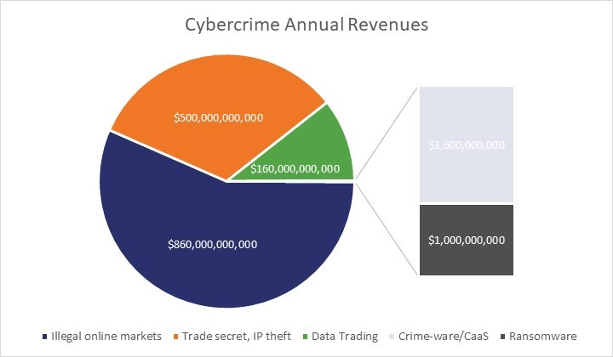
Re-Hashed: 2018 Cybercrime Statistics: A closer look at the “Web of Profit”

Cybercrime will generate at least $1.5 trillion this year—and that’s conservative
“The emergence of a complex and multi-layered cybercrime economy has also begun to suggest a fundamental shift in the very nature of crime itself. In this context, overt acts of crime become less central features of the criminal ecosystem when compared to the services and platforms that feed off and support crime – which become increasingly low-investment, high-yield and low-risk operations.”
Cybercrime will create over $1.5 trillion in profits in 2018
“By erring on the side of caution, by making projections from a small, rather than large number of revenue categories and by opting for lower, rather than higher points on the estimate range, the aim was to understand whether the assumption that cybercrime is a lucrative form of offending has any basis in what is actually happening within the cybercrime economy. The surprisingly high figures that were eventually derived certainly suggest that we need to think more seriously about the attractions and how these might be tackled. For even if the figure for total revenues from cybercrime is only accurate up to a point, the fact that it is a deliberately conservative one means that its inaccuracies at least involve only underestimates, rather than overestimates.”

291 cybercrime cases reported in Andhra Pradesh
VIJAYAWADA: Cases of online harassment and crime against women have seen a rise in the State with 291 cases being reported this year till now. Of the total, 138 cases were related to harassment through phone, e-mail, WhatsApp and social media abuse, while the remaining 153 cases were related to the leaking obscene information.
When TNIE asked the reasons behind the increase cybercrime, police officials explained that usage of smartphones among all age groups, free internet accessibility and lack of awareness on cybersecurity were the major causes. The officials further revealed shocking facts that more than 70 per cent of the victims were under the age of 20, while the rest being harassed at workplaces or colleges.
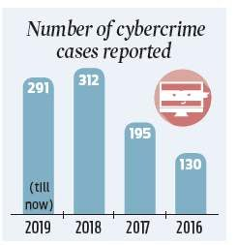
“In most of the cases, victims are being harassed by persons known to them. Some are due to data theft. Whatever may be the modus operandi, women should be careful while using smartphones and should not accept unknown people’s friend request on social media platforms,” said the official.
At a seminar held recently, Home Minister Mekathoti Sucharitha expressed dismay over the fact that technological advancement was contributing to the rise of cybercrime and violence against women.
Despite initiating various teams such as SHE Teams, Cyber Mitra and Mahila Rakshak for protecting the public from crime, technology was providing the wrongdoers with new ways to harass women.
“Majority of the cases are related to extortion, blackmail or personal grudge. To take such cases as top priority, DGP Gautam Sawang launched Cyber Mitra, which encourages women to file cases without coming to police stations,” police said. “Of the total, 18 per cent of the cases registered at police stations, were related to sexual harassment. Women can register a complaint against any cybercrime through WhatsApp number 9121211100,” said the DGP on Thursday.
Cybercrime cases reported in Arunachal Pradesh
Arunachal Pradesh Police takes immense pleasure in welcoming you to the website of Arunachal Pradesh Police. Arunachal Pradesh with its mesmerizing scenic beauty, rich tribal heritage and diverse culture is unique and distinct from other states of the country. Its remoteness and strategic location pose special challenges.Use of electronic medium is growing in the society and it can be an effective and quick way to reach out to the public. I call upon all the visitors to this site to derive greatest value from the services on offer through our website. Please also spare time to give your constructivc feedback in improving our services to the people. Arunachal Pradesh Police remains committed to provide transparent, responsive, just and people friendly policing with the motto "Satya, Seva, Suraksha. We, with the strength of more than 11,000 personnel, are ever committed to provide a safe and secure environment to all the people of the State.
Cyber Crimes Spurt in Assam
GUWAHATI: Assam has witnessed a sharp increase in cases of cyber crime primarily due to easy access to the internet by criminals and negative use of social networking sites.
The State has the highest number of cases registered under cyber crime in the entire Northeast. Figures available with the Assam Police show that the number of cyber crime cases in Assam registered under the provisions of Information and Technology Act, 2000, leapfrogged from 379 in 2014 to 483 in 2015 followed by 696 in 2016, 1267 in 2017 and 868 upto June in 2018.
“With the rising popularity of social networking sites, there has also been an increase in the cases of defamation on those sites,” a police official said. The police is increasingly receiving a number of cases related to defamation, threats and personal attacks made through social media.
Assam Police have, however, added more teeth to its capability to combat the emerging cyber threats with the commissioning of a cyber dome and a digital investigation and technical analysis centre.
Cyber crimes reported in Bihar
Addressing a workshop organised by Bihar Industries Association (BIA) here on Saturday, the EOU officials appealed to the people to conceal their personal and private information in order to prevent cybercrime.
Participants at the workshop were made aware of different types of cybercrime, such as phishing, harassment, cyber stalking, cyber pornography and morphing, through a power-point presentation.
Cyber crimes reported in Chhattisgarh
Chhattisgarh: Over 700 cyber crimes registered in last three financial years
Raipur, Nov 27 (UNI) About 781 cases of cyber fraud were registered in Chhattisgarh in the last three financial years and maximum 225 cases were reported in the capital Raipur, Home Minister Tamradhwaj Sahu gave this information in written reply to the question of Congress MLA Arun Vora in Chhattisgarh assembly on Wednesday.
Sahu said that 144 cases were reported in FY 2016-17, 359 in FY 2017-18 and 278 in FY 2018-19. Bijapur, Sukma and Narayanpur districts registered two cases each during this period.
He said that 201 out of 781 cases of cyber fraud were sent to the court for prosecution. Cyber cells have been formed in all the districts to check cyber fraud. "These cyber cells will
provide technical support to the police stations by conducting technical analysis of the cases," he said.
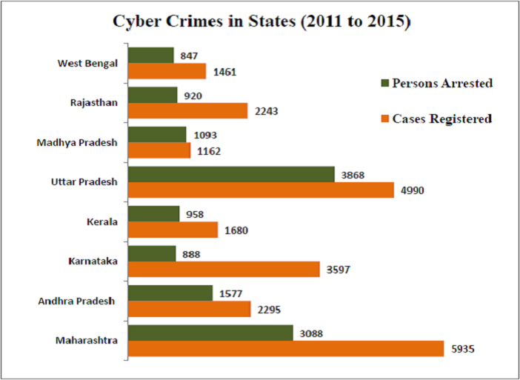
Sahu further said that cyber lab had been set up in police headquarters. Cyber lab to conduct training to deal with cyber crime has also been set up in police academy, Chandrakhuri. "Moreover public awareness drive is conducted at regular intervals for prevention of cyber fraud," he informed.
UNI AS-RK RHK1523
Team names and registration numbers
P.Bhavitha-9919004212,
G.Mounika-9919004099,
B.Kusuma-9919004032,
K.Bindu priya-9919004144.

